Measuring blood glucose with blood glucose meter

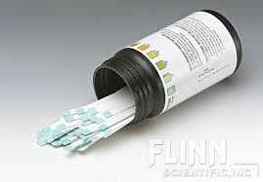

Image : teststrips

Step 1: Perform handhygiene (use handhygiene)

Step 2: Clean workfield (use table)

Step 3: Ask client to wash his hand with soap. (diaglog -> wash your hands please)

Step 4: Check expiration date of the teststrips (image1) (examin teststrips)

Step 5: Place lancet (see image2) within the pricking pen (combine lancet + pricing pen)

Step 6: Turn on blood glucose measuring tool (see image 3) and place the teststrip

* Step 6.1: turn on glucose measuring tool (pick up tool -> use)
* Step 6.2: Place teststrips in the blood gluose measuring tool (combine teststrip + glucose measuring tool)

Step 7: put on gloves (pick up gloves -> use)

Step 8: Check if injectionspot is warm ( examine-> patient finger)

Step 9: Inject pricking pen on the side of the finger top (UseON pricking pen -> patient)

**Start animation sequence**

* Inject prickingpen on the side of the finger top -> right choice
* Inject pricking pen on top of the finger top -> wrong
* Inject needle in the nail of the patient -> wrong
* Leave

*If choice is right -> show animation, after animation show new dialog cirkel.*

***!!!Used pricking pen is removed from the players hands and spawned on the table!!***

Step 10: Do NOT push the vinger to get blood droplet.

* Do NOT push the vinger to get blood droplet -> right
* Push the vinger to get blood droplet -> wrong
* Pull the finger to get blood droplet-> wrong
* Leave

*If choice is right -> show animation, after animation show new dialog cirkel.*

Step 11: Whipe away the first blood droplet away with cloth (to ensure blood droplet is not contaminated.

*(cloth will be implemented within animation to make it easier, else the player has to quit animation to get cloth)*

* Whipe away the first blood droplet away with cloth -> right
* Collect blood droplet -> wrong
* Inject second time -> wrong
* Leave

*If choice is right -> show animation, after animation show new dialog cirkel.*

Step 12: Fill teststrip with the blood drop, filling the whole testfield of the teststrip. Do not smear the blood and do not touch the testfield of the teststrip.

*(teststrip combined with blood glucose measuring tool will be implemented within animation to make it easier, else the player has to quit animation to get (teststrip combined with blood glucose measuring tool)*

* Fill teststrip with the blood drop, filling the whole testfield of the teststrip -> right
* Fill teststrip with the blood drop, NOT filling the whole testfield of the teststrip -> wrong
* Fill the teststrip with blood by smearing it over the the testfield -> worng
* Leave

*If choice is right -> stop animation sequence.*

Step 13: Read the blood glucose values of the blood glucose measuring tool (Use)

Step 14: Remove teststrip from blood glucose measuring tool (Combine)

Step 15: Throw teststrip in the needle trashcan (UseOn)

Step 16: Remove lancet from pricking pen (combine)

*!!Player has to pick up the combined pricking pen with lancet that spawned onto the table afeter step 9!!*

Step 17: Throw lancet in the needle trashcan (Use ON)

Step 18: Remove gloves (empty hand -> Use: Only possible at this step not during rest of game)

Step 19: Preform handhygiene (Use)

Step 20: Write down values (use)

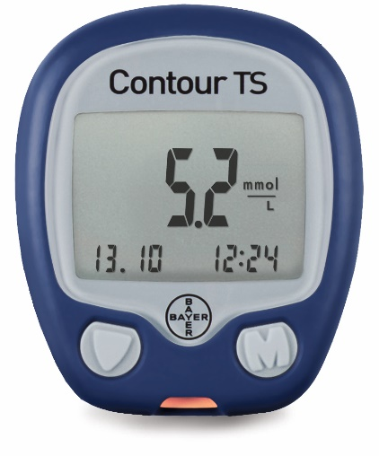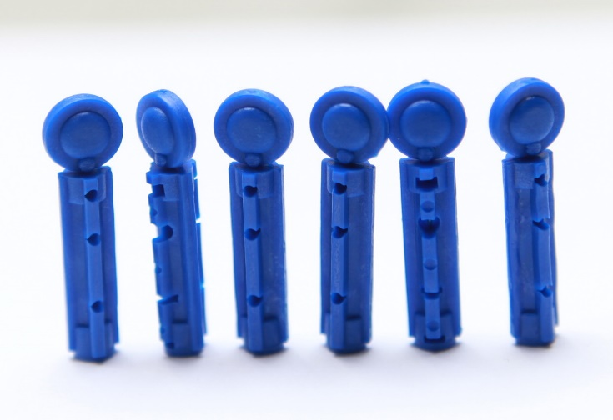

Image 3: Blood glucose measuring tool.

Image : Lancet